Flexible & Wearable Electronics
Application Experiments

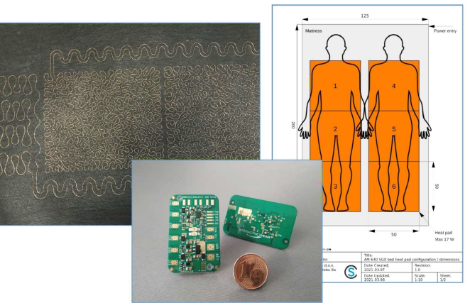

We follow the start up studio model helping corporations and entrepreneurs develop digitalization solutions for various industries

www.comsensus.eu

Problem to be solved
Heating, ventilation, and air conditioning (HVAC) systems in the recreational vehicle domain, are perceived as a significant source of noise and vibration as well as very power demanding, which is especially problematic during sleeping hours when the vehicle is turned off and not always connected to a power source. Additionally, present HVAC systems are very space demanding, not ideal for a sector where small space changes imply large impacts on comfort and space perception by passengers.

Solution provided by SmartEEs
The project goal was to modernize the conventional heating systems, in the recreational vehicle (RV) sector, thanks to flexible and wearable electronics (FWE). Smart textiles were used to create an autonomous and hands-off heating system totally integrated within the existing textile in the vehicle Interiors and able to improve thermal perception and comfort of the living space while also improving energy efficiency of the vehicle (ex. caravan and motorhome). ComSensus (Slovenia) was responsible for providing the smart features and control capabilities as well as their integration with the electronics and the smart living solution of the vehicle; and Interactive Wear (Germany) designed and produced the custom-made heating pads that where integrated in the vehicles interiors.

Business model & impact
New heating solution for the automotive sector and in particular the recreational vehicles market. The developed smart heating fabric allows providing heat locally in the vehicle interiors and increases the user comfort while reducing the overall vehicle power consumption (i.e., localized heating of the passenger, without the need to heat the entire vehicle).

