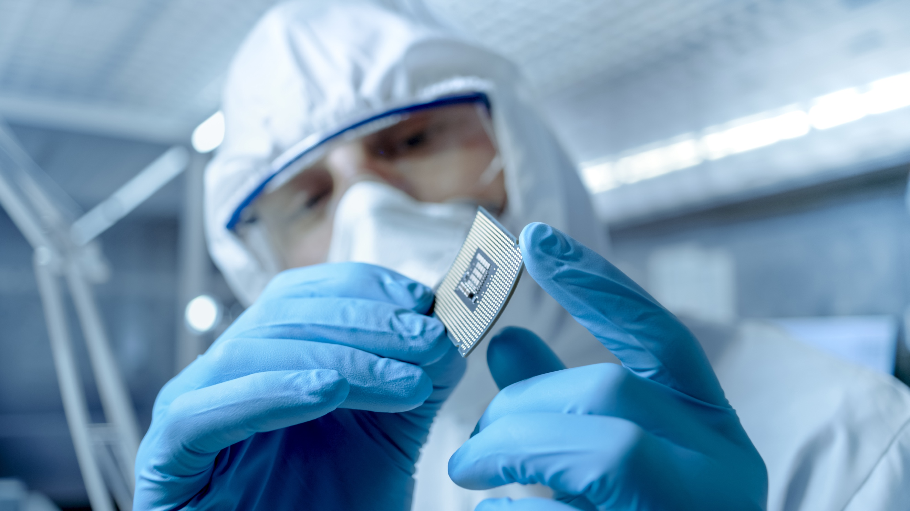
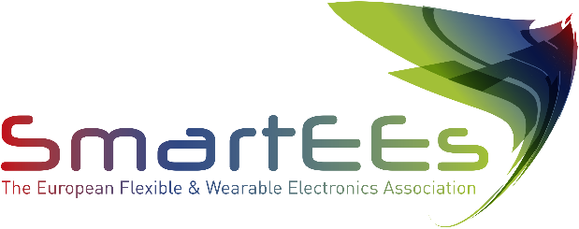
Flexible & Wearable Electronics
Application Experiments

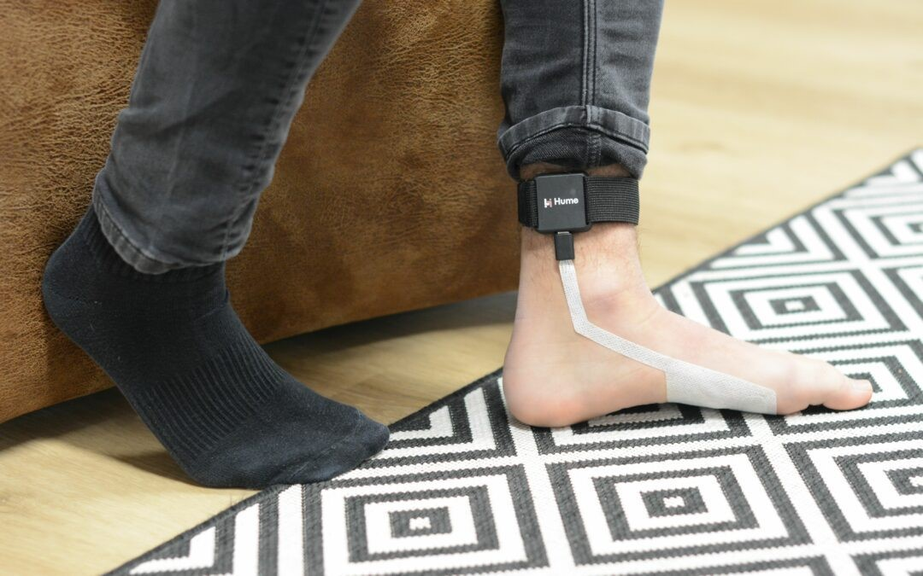

Mentech Innovation B.V.

To enhance the quality of life of vulnerable people through early stress recognition with smart wearables and smart algorithms

mentechinnovation.eu

Problem to be solved
The HUME is a streaming software platform for real-time stress detection, based physiological parameters and artificial intelligence models. The HUME is mainly used as a diagnostics tool for misunderstood behaviour in people with a severe intellectual disability or late stage of dementia. Back In 2019, a pilot study among care organizations made use of wrist-mounted wearables from third party manufacturers. During this period, the need of a custom wearable, integrated in the daily life of people with a severe intellectual disability or dementia has become clear. Clients with a severe intellectual disability often don't accept a wrist mounted device. Ideally, this new, tailored wearable device measures a range of physiological parameters in a way that is comfortable and unnoticeable for the client.

Solution provided by SmartEEs
This project resulted in a market-ready electrode patch to measure skin conductance on the foot of a client with a severe intellectual disability or dementia. Research and testing have shown us that a flexible electrode patch applied on the foot solves the problem of rejecting the device by providing more comfort for the user. The larger surface area to measure skin conductance, together with the application of a skin-adhesive, resulted in better skin contact and a higher signal quality, even in situations with high activity. Signal quality, robustness and comfort are key aspects of the patch design. This resulted in a disposable patch providing maximum comfort to the user and ensuring valid and stable physiological input data for the HUME system of MENTECH.

Business model & impact
The first market targeted by MENTECH is the market of vulnerable patients who, for any reason, can’t express their feelings and potential distress in order to prevent any acute crisis to arise. By enabling this stress management, HUME is enhancing the quality life of both clients and their caregivers. The HUME is currently in use In the Netherlands,Flanders and Austria in long term care organisations for disabled patients. By extension, thanks to the application experiment they are currently also exploring the market of burn-outs at work and the prevention of work-related stress and its potential harmful consequences.

