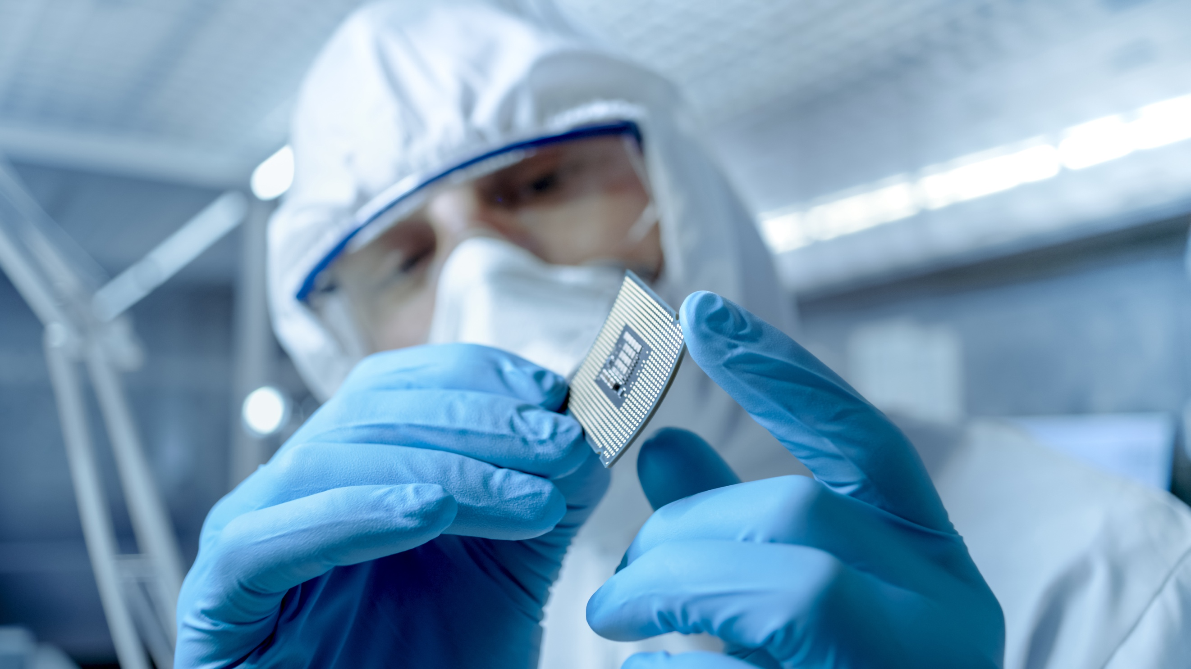
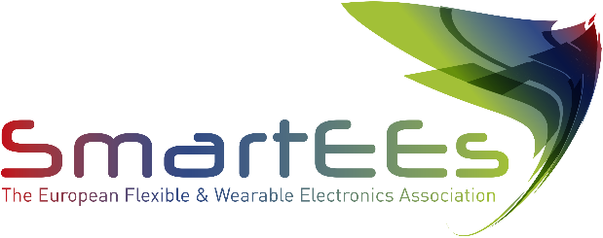

Flexible & Wearable Electronics
Application Experiments

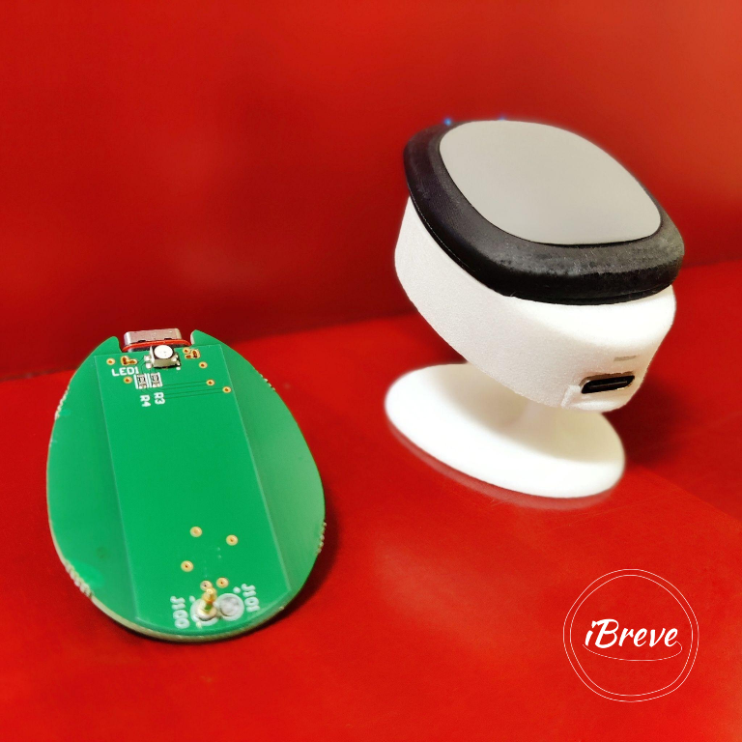

iBreve is developing wearable self-care solutions that focus on prevention & promote healthy living.

https://www.ibreve.com/

Problem to be solved

For many Covid-19 patients overcoming the acute infection is just the beginning of a long journey to recovery. Post-Covid Syndrome (PCS), also called Long Covid, is shaping up to be a major and long-term public health issue. Recent studies reveal staggering numbers, both on physical and mental health consequences: More than half of patients reported not being fully recovered 7 months after onset of Covid-19 symptoms independent of the initial severity of the infection. The overall goal of the Application Experiment (AE) was to transform the existing prototypes into a small series of product demonstrators to validate state-of-the-art production methods, i.p. validating manufacturing concepts through multiple iterative manufacturing cycles.

Solution provided by SmartEEs

iBreve developed a patent pending wearable technology to analyze respiratory patterns in real time and provide personalized respiratory training. Our solution aims to provide a novel approach for long covid recovery at home based on continuous monitoring of respiratory biosignals. SmartEEs enabled us to accelerate the product industrialisation and to manufacture a small series of product demonstrators. Together with our SmartEEs technical service partner we integrated new manufacturing technologies for high volume component assembly & flexible components.

Business model & impact

Our Business Model of Hardware Enabled Services ensures recurring revenue streams through services & incentivises to build sustainable hardware that lasts. SmartEEs produced valuable expertise in terms of manufacturing, handling a supply chain crisis and scaling wearable electronics. Key stakeholders of the value chain were identified and with our manufacturing partner in electronics integrated within the project. Finally we see benefits in the company’s competitiveness and ultimately in turnover, growth and new job creation.

