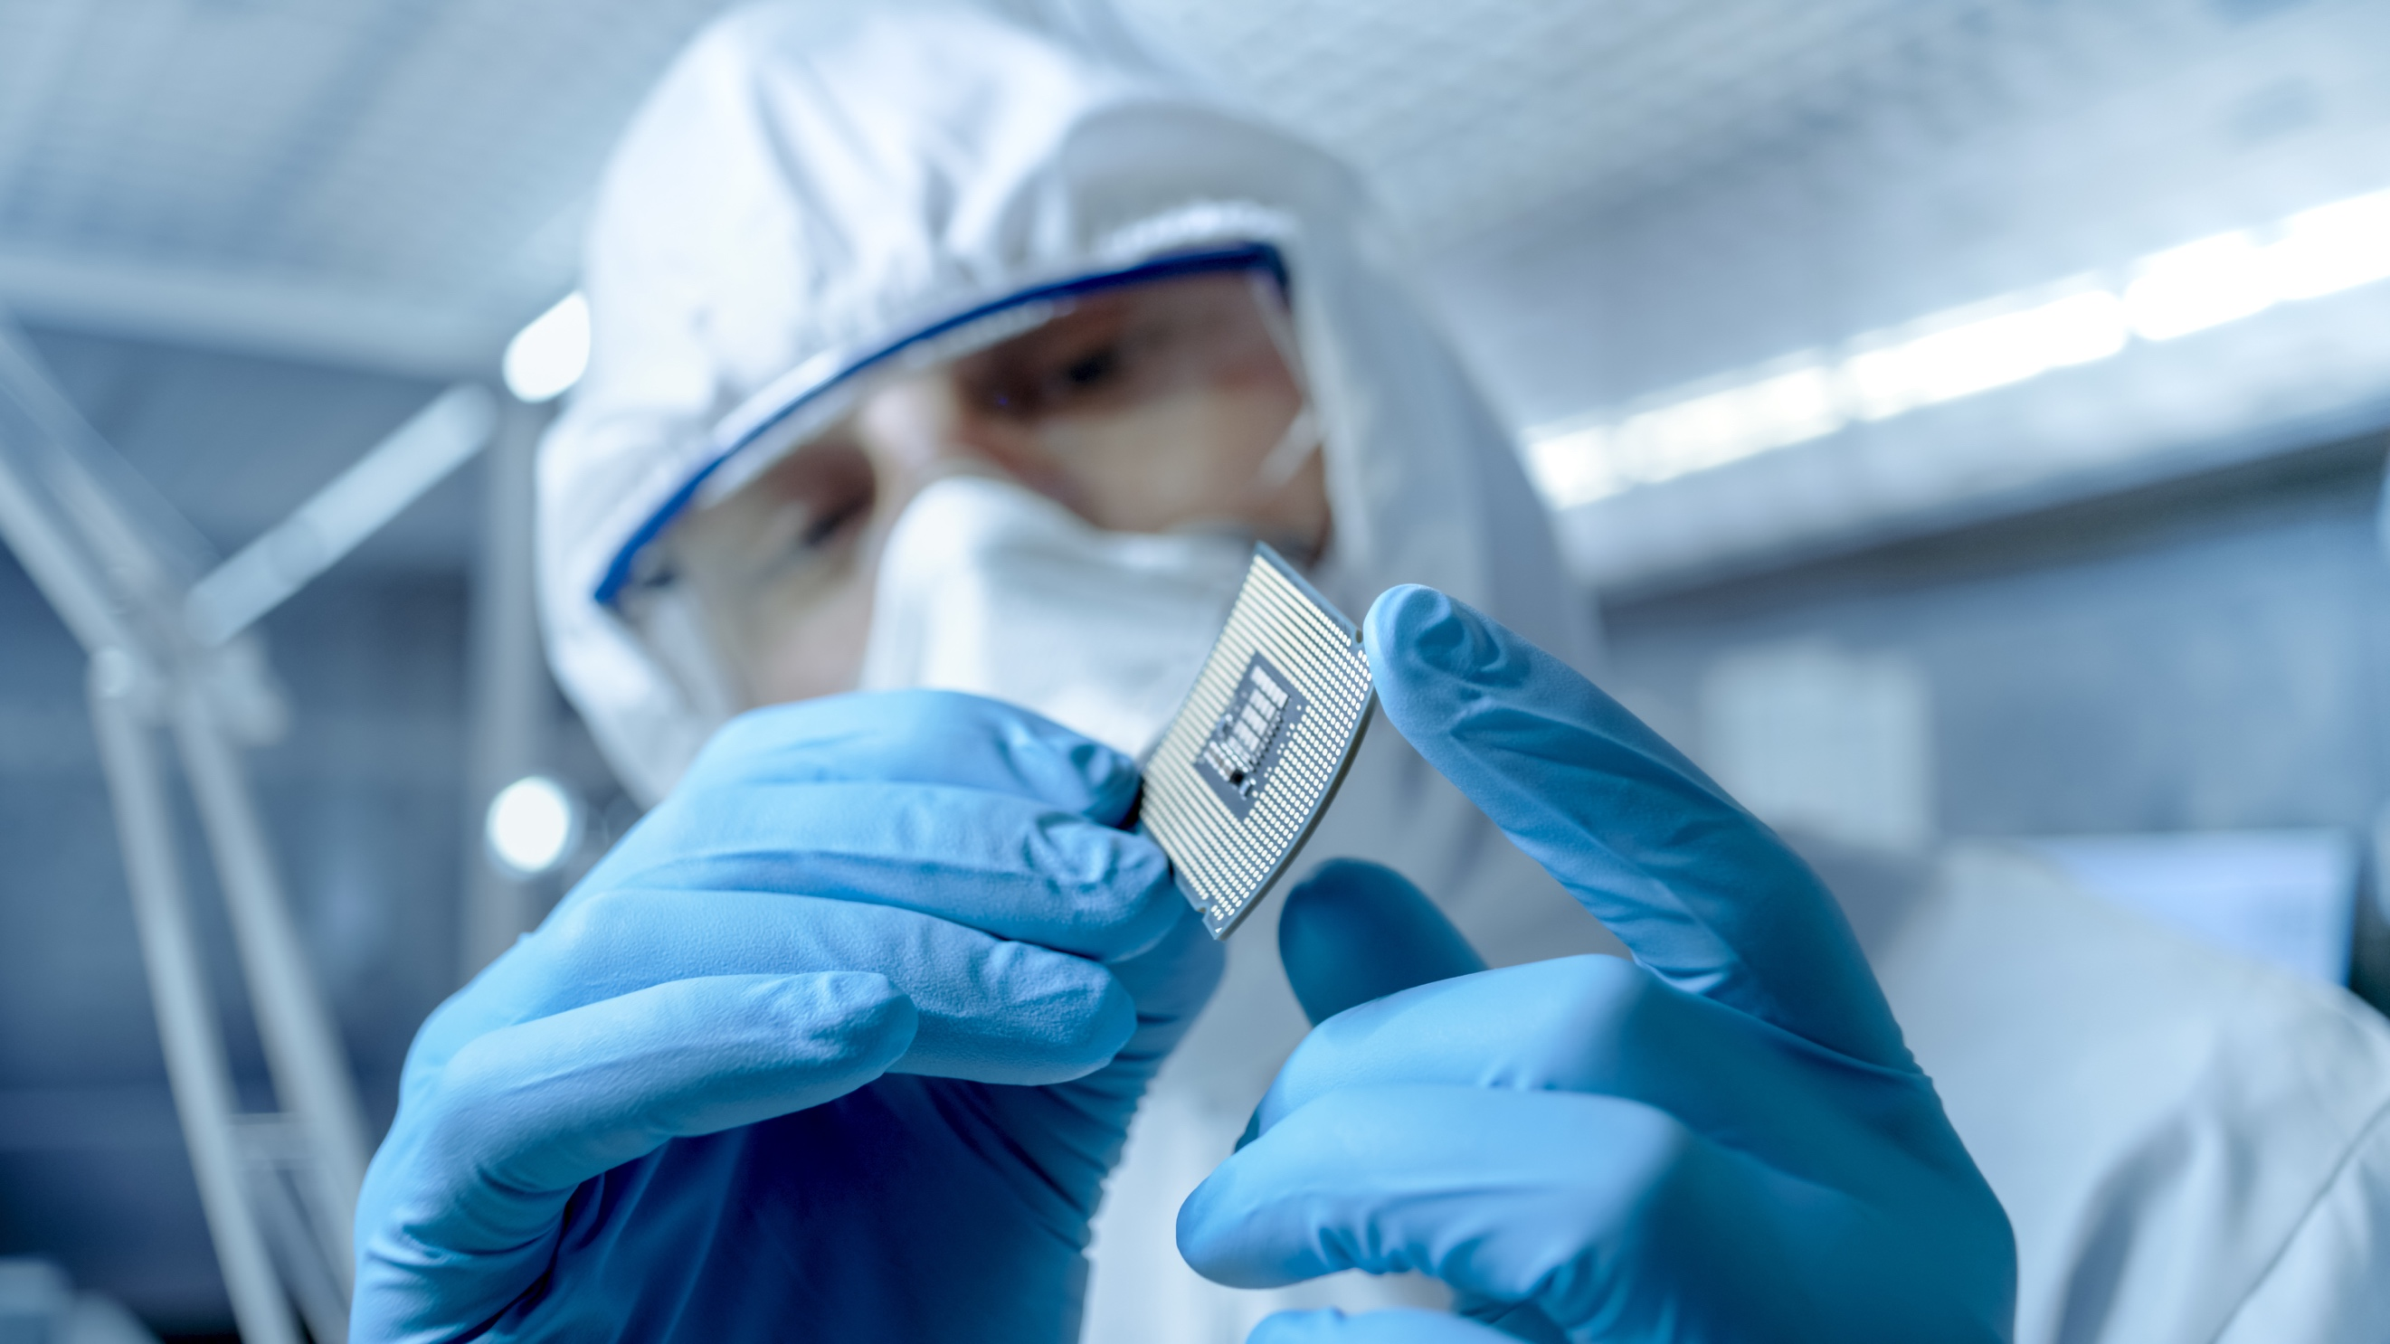
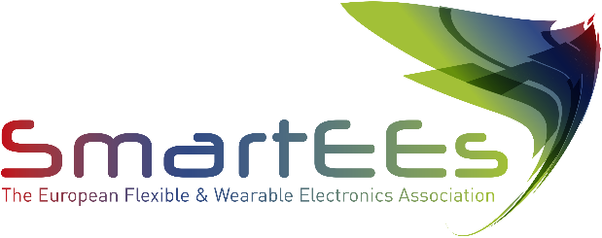

Flexible & Wearable Electronics
Application Experiments

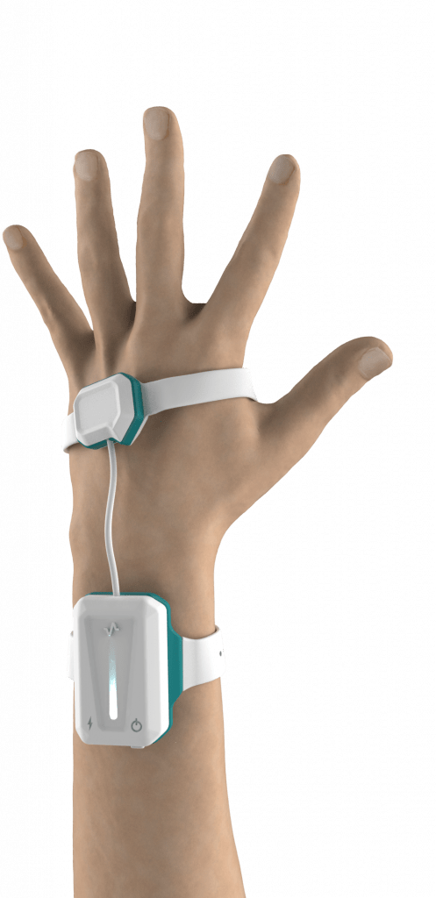

Limix is committed to improving people’s lives by transforming the results of scientific research into innovative technologies.

www.limix.it

Problem to be solved
A huge number of people worldwide suffer from speech disorders and impairments which result in a substantial inability to naturally or fluently communicate. The need to serve patients with speech disabilities deriving from extremely diverse medical conditions has suggested the development of devices capable to respond to the specific needs of each target group. Unfortunately, such assistive or augmentative communication (AAC) aids still prove scarcely patient-centered and not accessible because of their high cost, also having significant technological limitations affecting conversational rates and performance.

Solution provided by SmartEEs
e-Glove is medical assistive wearable device able to translate hand gestures into words in real time, targeted to patients suffering from impairment in verbal communication. As demonstrated in relevant environment, the device can detect hundreds of different gestures and translate them into words thanks to an APP and speech synthesizer on a smartphone. The SmartEEs experiment, has been focused on eGlove's fingers sub-system, helped to verify the technological feasibility of a flexible, trying to elaborate a wearable solution enhancing ergonomics, mechanics and usability, through the development of a lighter and more comfortable solution respect to the wired one.

Business model & impact
e-Glove is a smart solution to communication problems stemming from any disease affecting language, with particular focus on post-stroke patients, whose number is expected to increase by +35% in the EU in the period 2015-2035, since the device helps to remove fundamental obstacles to an active participation in social life and supports rehabilitation. The SmartEEs experiment has supported LiMiX in a thorough market analysis, in the validation of the business model and in outlining the needs of each end-users group, also investigating possible paths for receiving the financial support needed to develop, industrialize and produce e-Glove.

