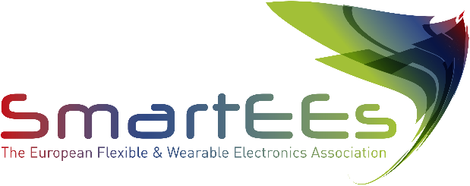

Flexible & Wearable Electronics
Application Experiments

ARPE is a small family business founded in 1991 that designs, manufactures, cuts, sews and stamps in Barcelona customized microfiber products for the promotional products sector, cultural sector, optics and optometry, automotive, gymnasiums and collectives. Since its foundation, the company has maintained its own production Km0, capacity for innovation and development of new products, as well as its growing commitment to sustainability and the circular economy.

www.arpe.es

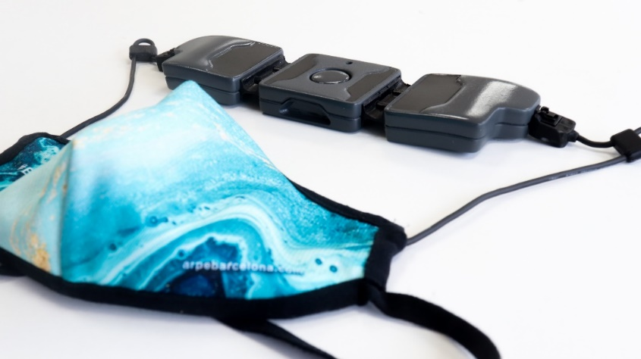

Problem to be solved

Current washing requirements for textile masks require standalone washing cycles at 60ºC (aggressive temperature for the fabrics and polluting of large amounts of water). Therefore, the main challenge is the development of a textile with an integrated disinfection system, reducing the washing requirements of the mask, without compromising user safety.

Solution provided by SmartEEs

SMART-MASK prototype uses heat to denature and deactivate potential viruses within short timeframes (3 minutes) by heating the facemask at 76ºC. It consists in a smart hygienic facemask, with a resistive yarn pattern on the inner layer and customized electric interconnections for powering it up. The current solution also includes the application of humidity and temperature sensors in the facemask, to regulate the heating systems applied. Both the heating and sensing systems interact wirelessly with a mobile app, providing all the necessary data to the end-user.

Business model & impact

ARPE’s reusable smart face mask is targeted at the general population and should be used to prevent COVID-19 spreading among other measures, such as social distancing. The target market is Europe accounting for 746 million people. Therefore, the total addressable market (TAM) is about €74.6 billion, manageable by selling the product at an average price of 100€ to those 746 million people. According to recent data, the rate of adoption of reusable face masks vs. medical-grade masks is around 12%, making it an attractive €9 billion market opportunity for the company. To take advantage of this opportunity, ARPE’s sales strategy related to SMART reusable face masks largely will rely on three main channels/revenue streams: Business-to-Business (B2B), Business-to-Business-to-Consumer (B2B2C) and Business-to-Consumer (B2C). The SMART-MASK technology will expectedly extend the current portfolio products towards smart textile electronics with improved sustainability and lower carbon fingerprint.

